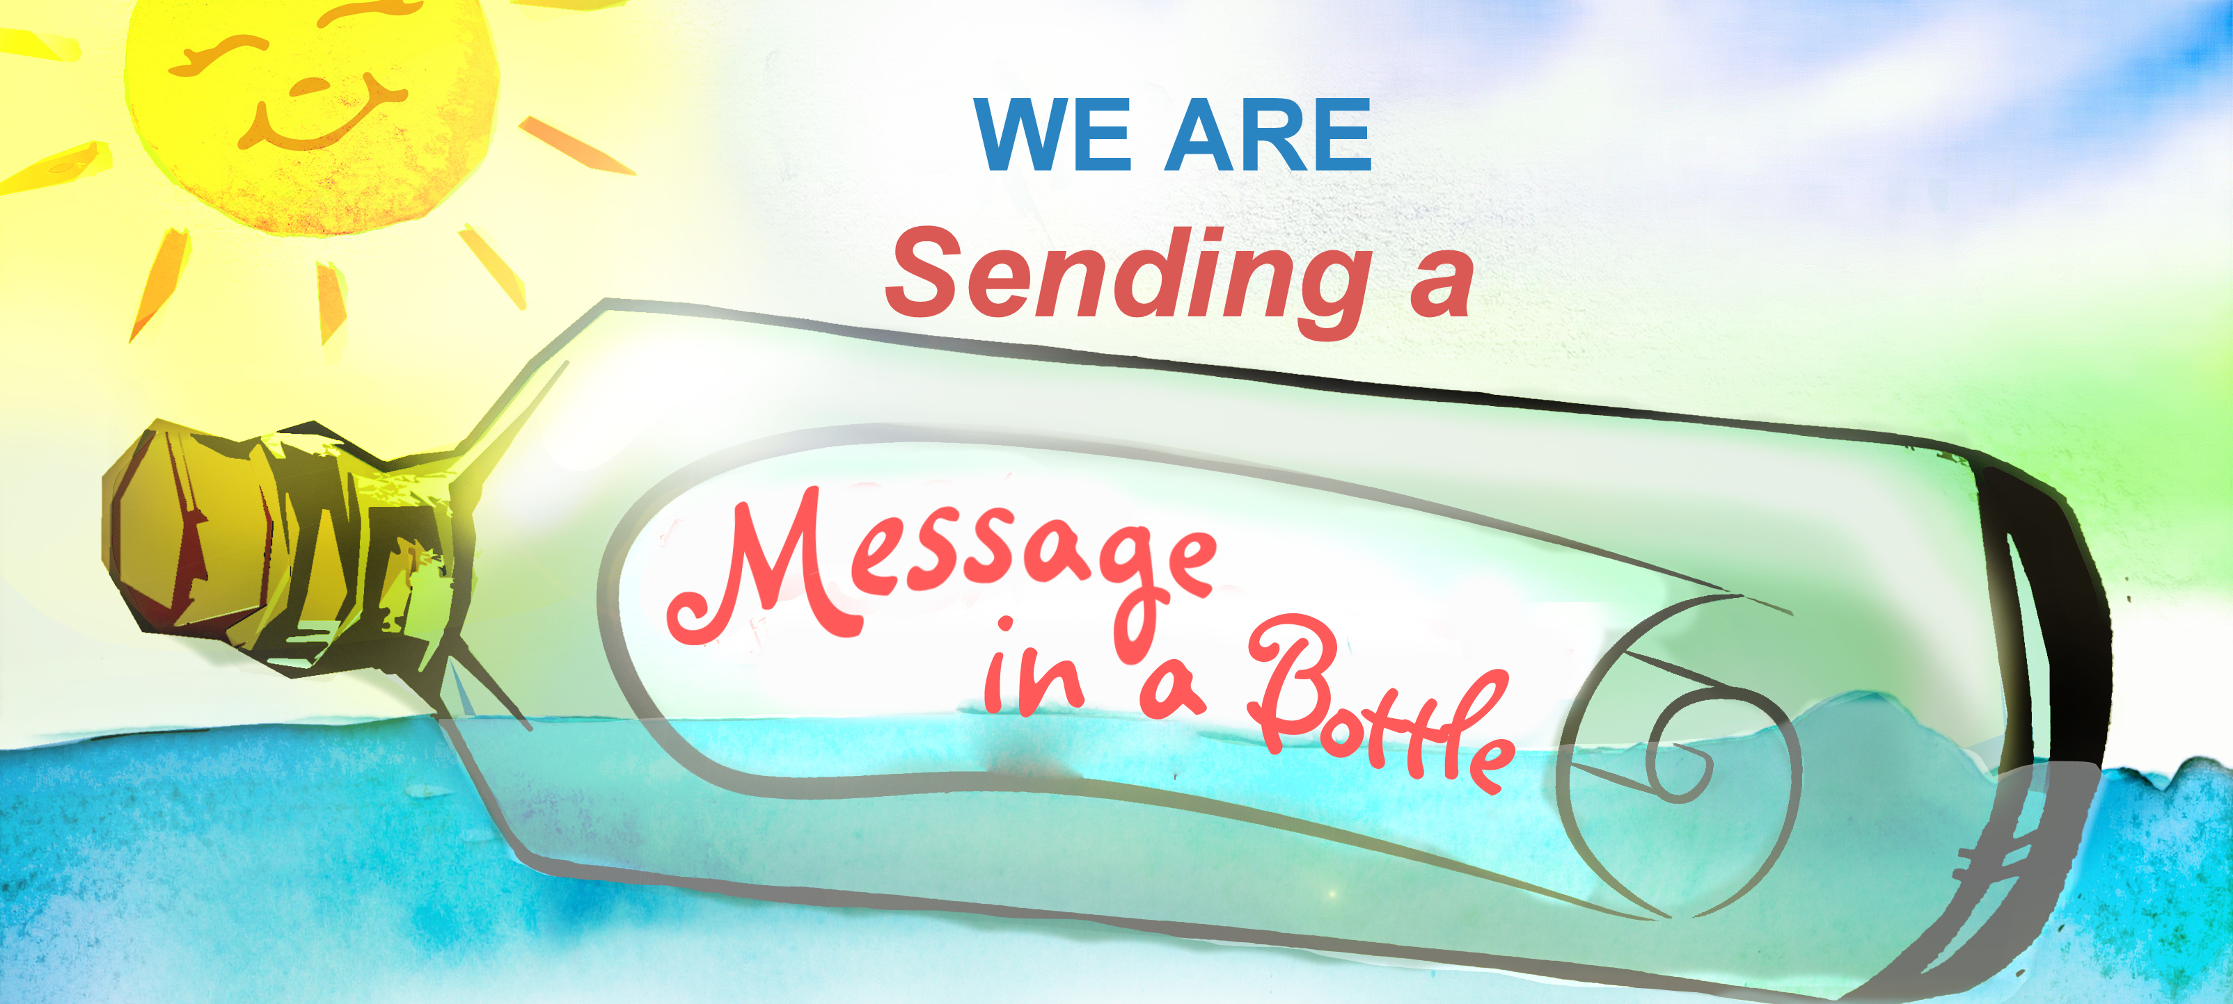
Business checklist.
- Business name.
- Contact name.
- Discuss plastic use and reduction.
- Given to customers.
- Sold to customers.
- Received from suppliers.
- Recycling offered to customers or other businesses.
- Display poster.
- Promote on social media and on website.
- Raffle prize for fundraising (to purchase shopping bags to promote plastic-free shopping by schoolchildren and families).
- Maintain clean street and gutters outside premises – instruct staff.
- For takeaways, ask if they can display ‘we wrap food in paper’ poster.
- For publicans, ask if they can:
- Supply ashtrays.
- Display ‘cigarette’ posters.
www.sendingamessageinabottle.co.uk
Follow us on Facebook

