We made our work cross curricular and highlighted in bold are skills relating to the new 2020 curriculum for Wales.
GEOGRAPHY/SCIENCE
We watched Blue Planet 2 and discussed the issues highlighted by David Attenborough about plastic.
We took a walk around school to find out where plastic is being used and to see if we can reduce it.
We held a “Big Blue Day” wear every child dressed in blue and joined in an environmental workshop with the charity Marine Conservation Society. This is free of charge, available to all schools, but we held a raffle for eco prizes and donated £100. The charity provided a whole school presentation, followed by an hour workshop, specific to the age of each class.
Engage with contemporary issues based upon their knowledge and values
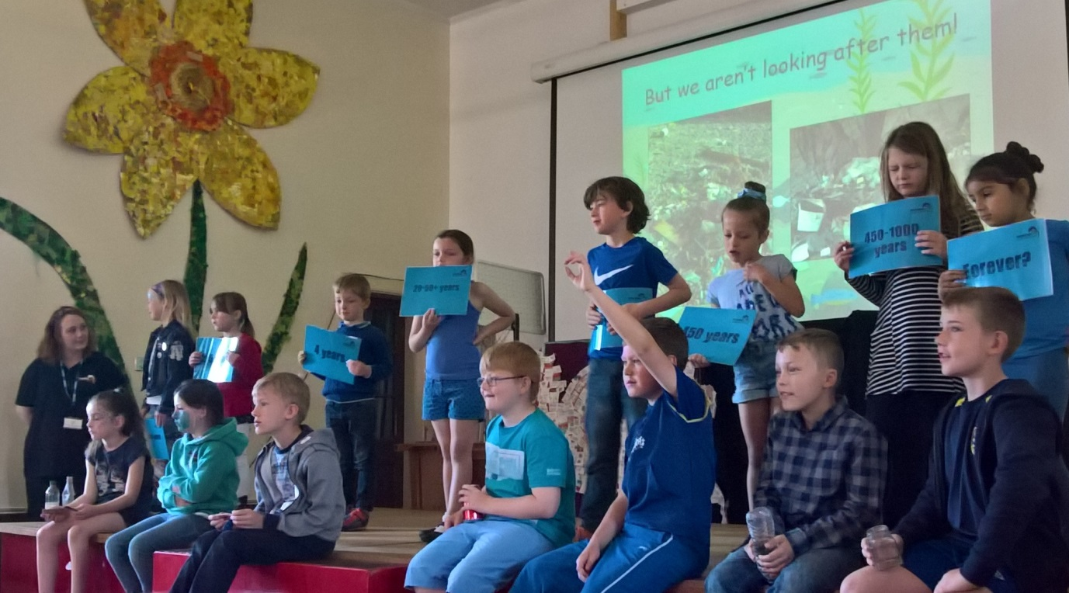
The whole school turned blue for The Big Blue Day event run by Marine Conservation Society!

