Some Lesson ideas to draw attention to the environmental issues surrounding plastic.
We made our work cross curricular and highlighted in bold are skills relating to the new 2020 curriculum for Wales.
LITERACY
The data really shocked us. So the pupils then wrote persuasive letters to Powys County Council asking them to look at how they purchased milk for schools. Writing purposefully for a real reason gave them much motivation. Letters were displayed in the local Arts Centre in a ‘Sending a Message in a Bottle’ display.
The pupils also used their artistic and collaborative skills to design large A3 posters to be used at the MIAB festival. The posters needed to be eye catching and persuasive to encourage less plastic and also recycling.
2020 curriculum for Wales.
- Understand and consider the impact of their actions when making choices and acting.
- Understand and exercise their human and democratic responsibilities and rights.
- Are building up a body of knowledge and have the skills to connect and apply that knowledge in different contexts
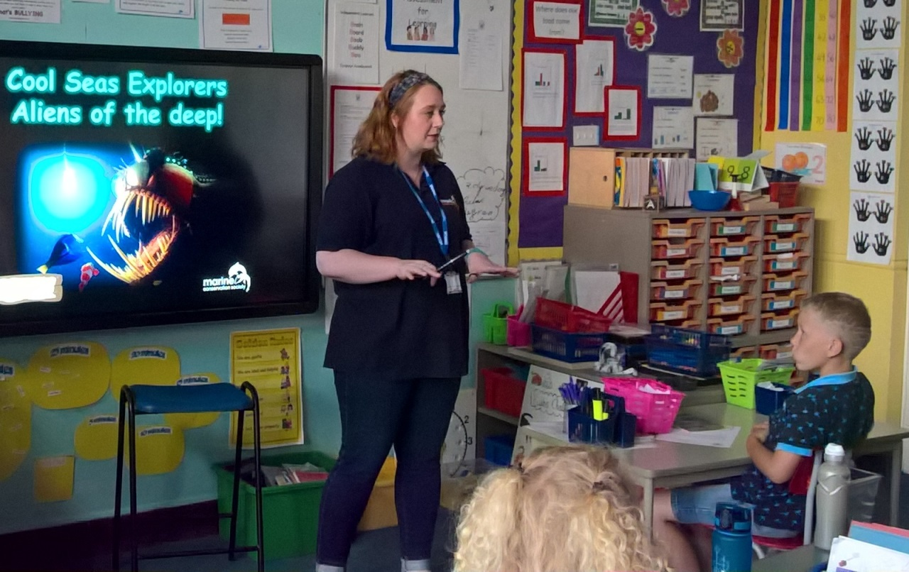
Workshops with Marine Conservation Society!

