We made our work cross curricular and highlighted in green are skills relating to the new 2020 curriculum for Wales.
SCIENCE AND HISTORY
We made a time line to show different materials and how long they take to decompose. Some plastics take up to 1000 years from now!!
2020 curriculum for Wales.
Find, evaluate and use evidence in forming views
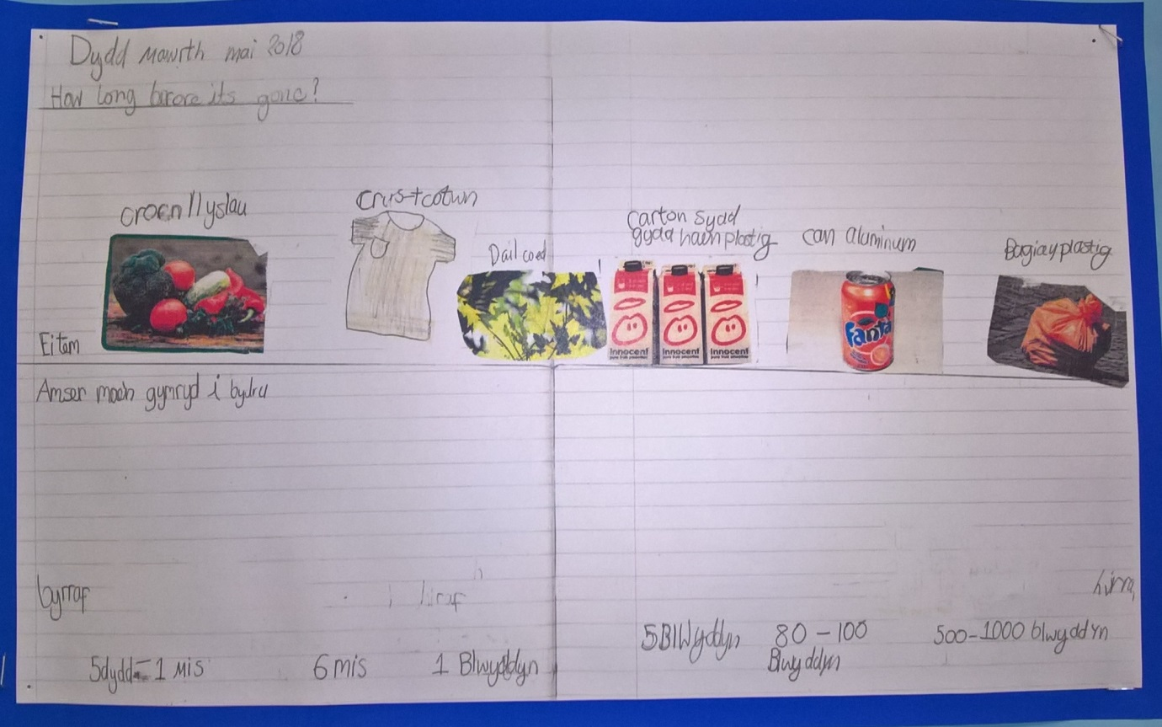
Bilingual poster created by the kids

