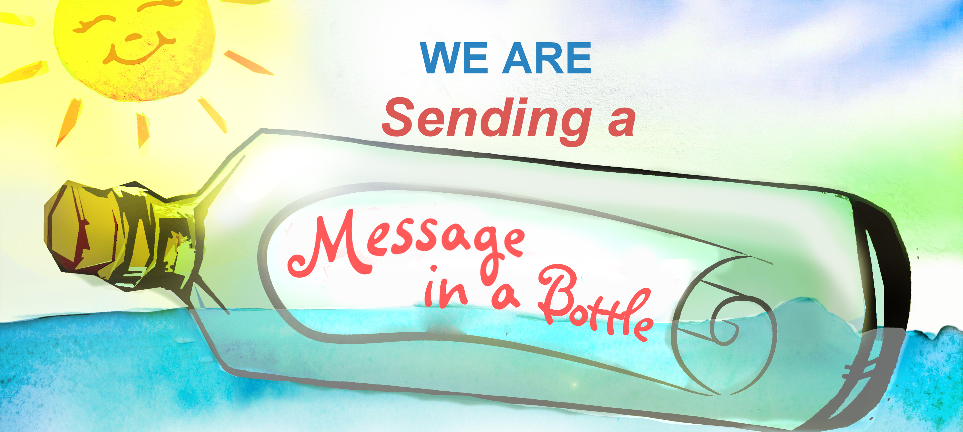
Dear (Supplier),
Working with ‘Sending a Message in a Bottle’, we are trying to reduce the amount of plastic we use and that we pass on to our customers. Our customers care about plastic use and have asked us to contact our suppliers. Please could you tell us how you are reducing plastic, especially single-use plastic, in your supply chain and do you have any plastic-free alternatives for me to use in my business.
Many thanks,

www.sendingamessageinabottle.co.uk

