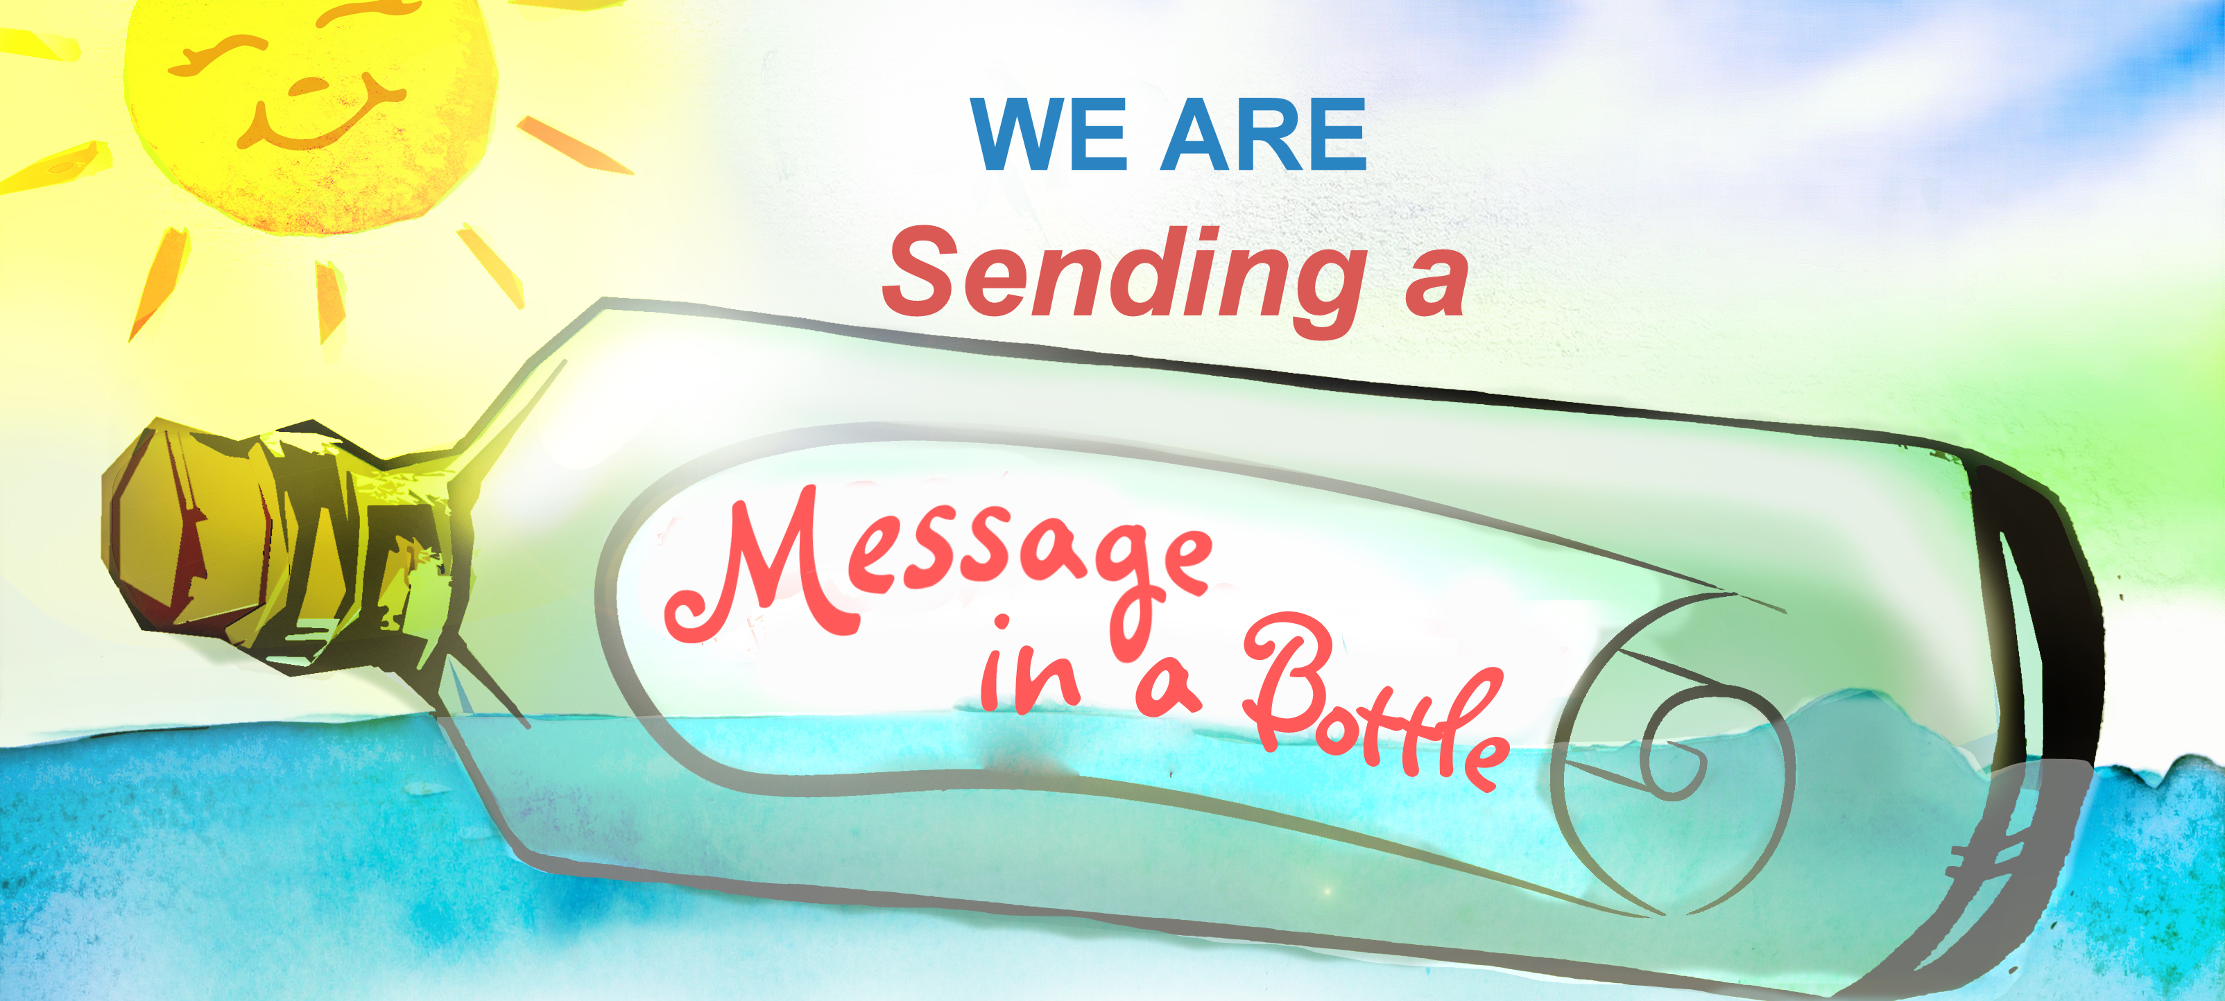
We can wrap your takeaway food in paper - just like in the good old days.
Please ask when ordering!

Thank you for helping us to help you reduce single-use plastics.
www.sendingamessageinabottle.co.uk

